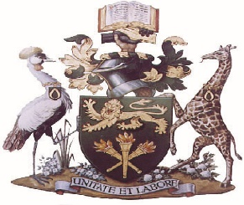

UNIVERSITY OF NAIROBI

COLLEGE OF AGRICULTURE AND VETERINARY SCIENCES

WANGARI MAATHAI INSTITUTE FOR PEACE AND ENVIRONMENTAL STUDIES

WMI ANNUAL REPORT- 2020

- Wangari Maathai Institute for Peace and Environmental Studies
The Wangari Maathai Institute for Peace and Environmental Studies (WMI) was established in 2009 as a centre of excellence in environmental governance and its linkages with peace and democracy. The Institute was established in close collaboration with the 2004 Peace Nobel Laureate, the late Prof. Wangari Maathai. WMI aims to promote good environmental practices and to cultivate a culture of peace by shaping values, ethics and attitudes of its graduates through experiential learning, mentoring and transformational leadership.

- Programmes offered
In 2020, the Institute offered the following programs;
- Master of Science in Environmental Governance
- Doctor of Philosophy in Environmental Governance and Management.

Short Course
- Environmental Impact Assessment and Environmental Audit Training

- Enrolled students in postgraduate programmes

In 2020, the Institute enrolled thirteen (13) studentsfor Master of Science in Environmental Governance and nine(9) students for Doctor of Philosophy in Environmental Governance and Management.

Out of the 22 students, 2 of them are International students i.e. Mr. SayKayTuagben, Reg. No.A82/57399/2020 from Liberia and Mr. Paulin MusuraReg. No. A60/37278/2020 from Burundi

- Number of graduates per programme

In the year 2020, the Institute graduated the following:
- M.Sc. in Environmental Governance 3
- Ph.D. in Environmental Governance and Management 3

- Research activities undertaken

- Sustainable Land Use and Management Systems (SLUSE 2020)

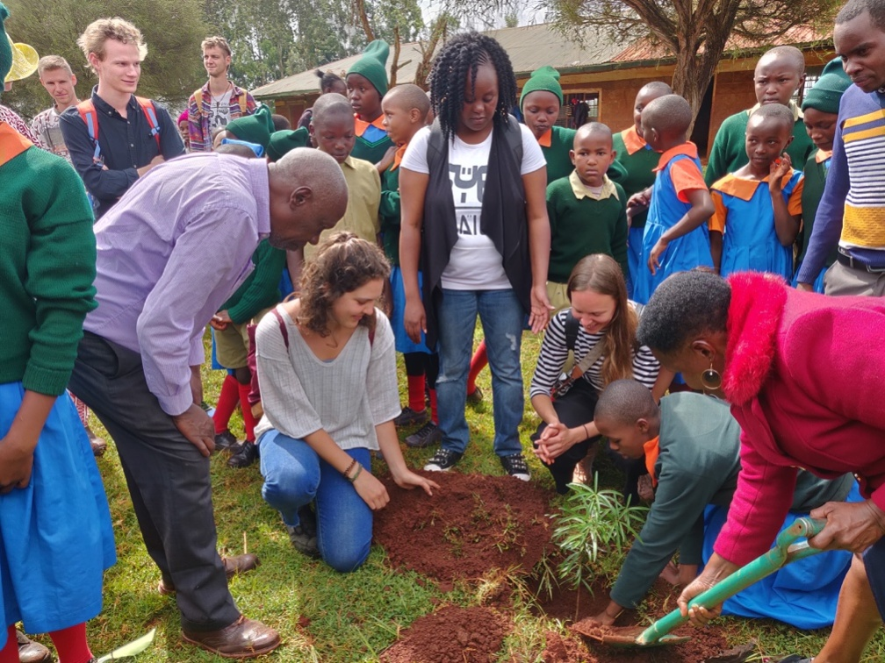

Planting trees at Gatugi Primary School, Othaya
The Wangari Maathai Institute for Peace and Environmental Studies in collaboration with the University of Copenhagen and University of Roskilde, Denmark successfully implemented the 2020 experiential field learning course dubbed, “Sustainable land use management system – (SLUSE),” which is the 8th in series after the SLUSE in 2012, 2014, 2015, 2016, 2017, 2018 and 2019. The program was held inOthaya, Nyeri County, from February 28 – March 10, 2020. The SLUSE 2020 covered 5 thematic areas i.e. Solid Waste Management, Crop Insurance, Soil fertility, Tea Certification and Karima Hill Community Forest. A total of twenty three (23) students from both University of Copenhagen and Roskilde University and eleven (11) from the University of Nairobi-Wangari Maathai Institute were involved in the SLUSE 2020. A policy brief on “Solid waste governance approaches to reduce conflicts and promote human and environmental health in Othaya Sub- County” was produced by the group whose theme was solid waste management supervised by Prof. MungaiProf. Müller-Stöver and Dr. Karatu.
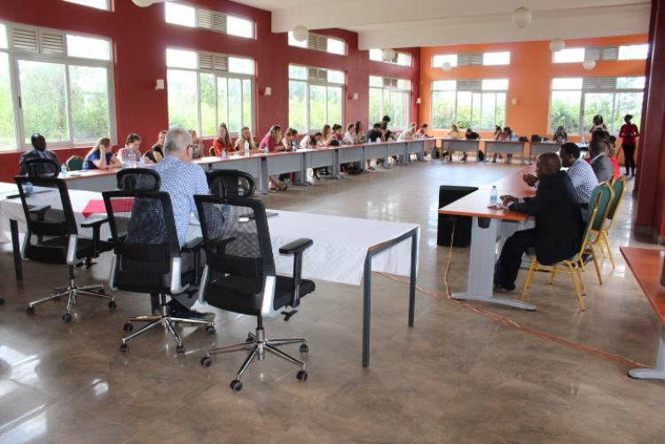
Students from the WMI-UoN, University of Copenhagen and Rothskile University, Denmark together with the supervisors during theSLUSE 2020 Closing ceremony on March 11, 2020
The Wangari Maathai Institute for Peace and Environmental Studies in conjunction with a representative from Tharaka Nithi County successfully conducted environmental sustainability- situational analysis in the County. The objective of the collaboration was to seek solutions towards achieving sustainable livelihoods through Integrated Environmental Restoration in the County.The institute appreciatedthe County for the collaboration and hoped to continue working together towards achieving the objective.

- International linkages and Collaborations

- Visit by senior high school students fromLinnankoski, Porvoo, Finland - 10/1/2020

The students were accompanied by Prof. Petri Pellika and their three teachers. The team was received by the Director, Prof. David Mungai. He gave them a lecture on climate change and its impacts particularly in Kenya/Africa. The visiting students were taken on a tour of the campus which emphasized the various experiential learning platforms.
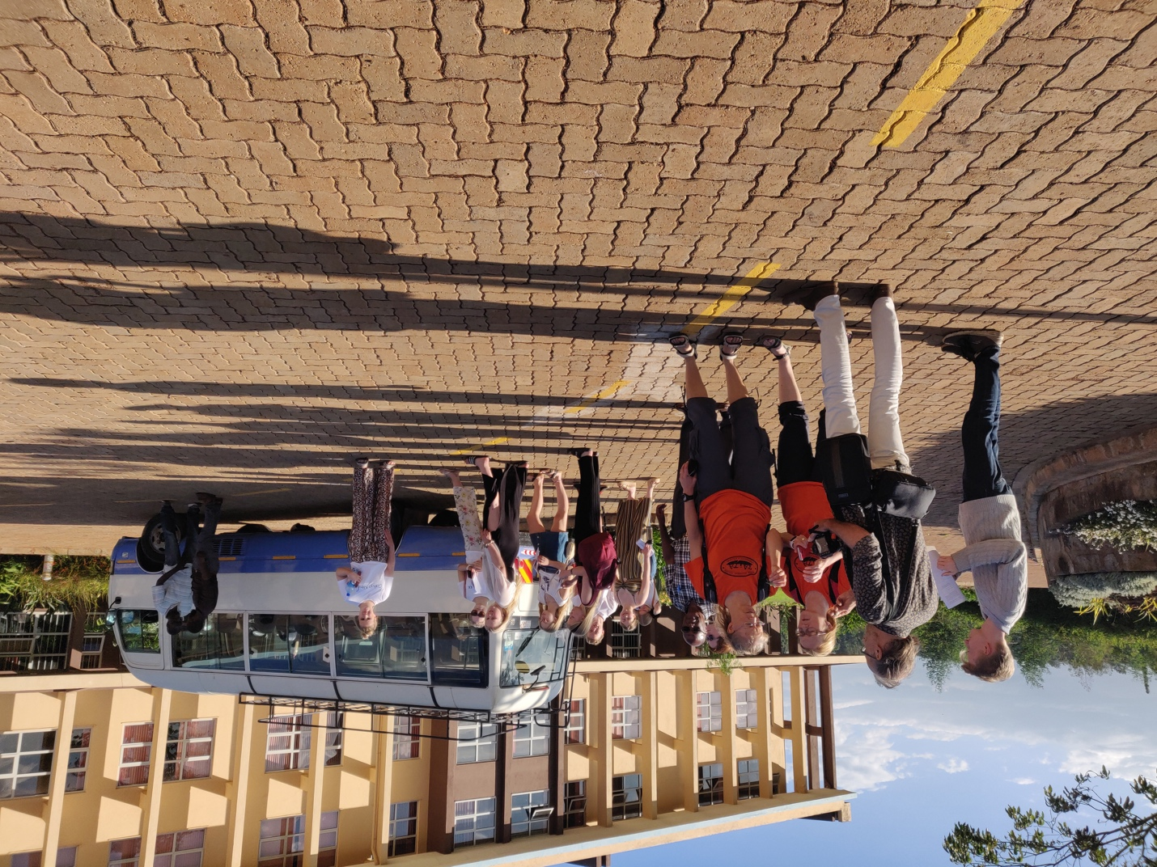
Senior High School Students from Finland Visiting the Institute on 10/1/2020

- Visit by a team of scholars from Trent University, Canada - 14/1/2020

The team was led by Prof. Neil Emery, Vice President (Research). With the team was the Vice Chancellor, Prof. Stephen Kiama. The meeting discussed areas of collaboration between the two institutions and the need to have a MoU.

- 9th February, 2020: The Vice Chancellor (Prof. Stephen Kiama) led a high-level team from the University of West Indies, Caven Hill which was led by the Prof. Vice Chancellor, Prof. EudineBarriteau. Accompanying the team were senior officials from the Ministry of Education and Ministry of Foreign Affairs. The Vice-Chancellor was accompanied by the Principal, CAVS, Principal, CHS and the Deans the College of Agriculture and Veterinary Sciences. The meeting discussed areas of potential collaboration in teaching, research and and students/staff exchange between the University of Nairobi and the University of West Indies

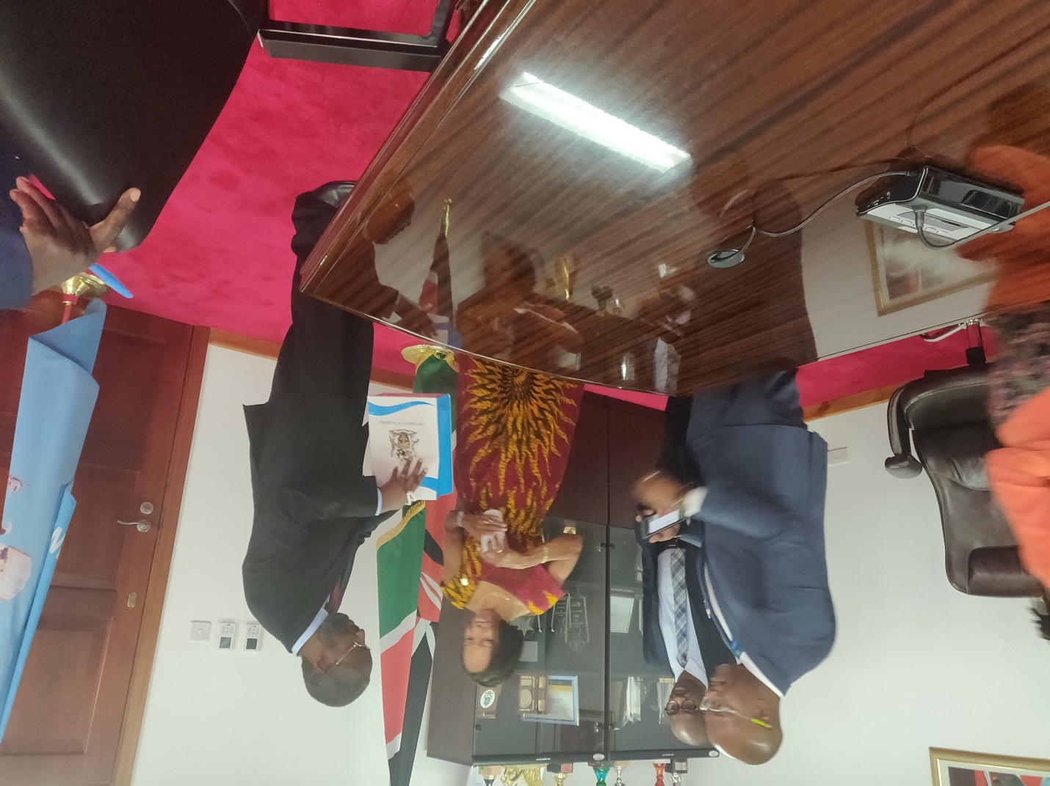
Prof. Eudine Barriteau receiving a gift from the Vice Chancellor, Prof. Stephen Kiama at the Institute’s Boardroom

- Visit to WMI by Ms. Luisa Fragasa - Head of Mission, Portugal - on 25/6/2020

The Portuguese Head of Mission in Kenya was accompanied by the Vice Chancellor, Prof. Stephen Kiama, Principal, College of Agriculture and Veterinary Sciences and the Principal, College of Humanities and Social Sciences. The meeting explored potential areas of partnership between the University of Nairobi and like minded Portuguese institutions.

- The Institute continues to be one of the Centres of Excellence in Earth System Governance Research and Training. It is affiliated to the Earth System Governance Project which is based at the Utrecht University in the Netherlands.

- The Institute continues to collaborate with the government of Kenya in sponsoring students to do their research under its sponsorship e.g. Kenya Climate Smart Agriculture Project (KCSAP), Kenya Forestry Research Institute (KEFRI) among others.

- Mediation Training Workshop at the Wangari Maathai Institute

The Wangari Maathai Institute (WMI) hosted a mediation training workshop from February 10, 2020 to February 14, 2020. The event was conducted at the Wangari Maathai Peace Laboratory and involved representatives from Kenya Forest Service, Kenya Forest Research Institute and members of the Ngong Hills Forest Community Forest Association. The training was carried out by Professors VibekeVindelov, Jens Emborg, Wahome, Karanja, Dr.ThuitaThenya and Dr. JoramKagombe.
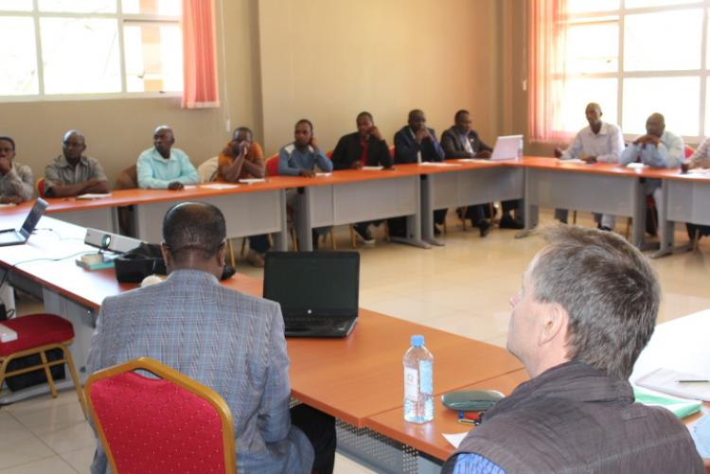
Dr. Karanja Njoroge and Prof. Jens Emborgduring one of the sessions of mediation training workshop, February 12, 2020

- Publications and presentations for the year
Harmsen, H., Wang'ondu, V. W. Mbau, J. S., &Muthama, N. J. (2020). Randomized hotspot strategy is effective in countering bushmeat poaching by snaring. Biological Conservation, 253, 108909. This does not belong to 2020?
Manoa,D. O., Mwaura, F., Thuita, T., &Mukhovi, S. (2020). A Review of the Visible and Hidden Opportunity Costs of Human-Wildlife Conflict in Kenya. J Biodivers Manage Forestry 9, 2, 2.
E Geoffrey, J Mutune - Kenya Policy Briefs (2020) Revisiting Kenyan’s Ban on Plastic Carrier Bags - Where was this submitted?
Edema, G.T.E., Karatu, K., & Edward, Aget the name of this author. (2020). An evaluation of the environmental impact assessment practice in Uganda: challenges and opportunities for achieving sustainable development. Heliyon, 6(9), e04758.
Ang'u, C., Muthama, N. J., Oludhe, C., &Chitedze, I. (2020). The role of diversity, reserve margin and system structure on retail electricity tariffs in Kenya. Heliyon, 6(8), e04626.
Togoch, H. K., Irandu, E.,M., &Thenya, T. (2020). Patterns of Livelihood Diversification among Kamnarok National Reserve Adjacent Communities in Baringo County, Kenya. Journal of Sustainability, Environment and Peace, 3(2), 55-62.
Mwakesi, I. W., Wahome, R. G., &Ichang’i, D. W. (2020). Mining Impacts on Society: A Case Study of Taita Taveta County, Kenya. Journal of Environmental Protection, 11(11), 986-997.
Mwakesi, I., Wahome, R., &Ichang'i, D. (2020). Mining impact on communities’ livelihoods: A case study of Taita Taveta County, Kenya. AIMS Environmental Science, 7(3), 286-301.
Kumunga, E., Ndiwa, T. C., &Nzioka, J. M. (2020). Towards a framework for monitoring and communicating water resources sustainability: A case study of Rwamuthambi Sub Catchment area, Kenya. Journal of Sustainability, Environment and Peace, 3(1), 21-33.
- Papers presented at conferences/workshops –
The Institute has held several webinars despite the Covid 19 Pandemic. The key ones include:
Prof. Stephen Kiama; Webinar, My Reflections of Prof. Wangari Maathai; Part of UoN at 50 Celebrations, the Wangari Maathai Institute Held on November 4, 2020
Cohen Ang’u: Conference presentation ; Role of Energy Sources on Rural Electricity Tariffs in Kenya, Held between October 21- 23, 2020
Prof. Nzioka John Muthama, Conference Presentation; Women, Climate Change indoor environmental Quality and Covid- 19 pandemic Held on October 14- 16, 2020
Prof. David N. Mungai: Attended a Planning Workshop on: Green Infrastructure for Sustainable Urban – Rural Development in Kenya (GI4SURD) held on October 9, 2020
Prof. Nzioka John Muthama; Conference Presentation; Transition to Green Growth in KENYA: Horticultural Productivity, Fuel Consumption and Shortlived Climate Pollutant Nexus Held on October 5- 7, 2020
Prof. Kahuziko Takeuchi; Establishing a decentralized and connected society for localizing SDGs in the Face of Covid 19 on September 23, 2020.
Muthama J. Nzioka. International Virtual Symposium on “Climatological, Meteorological and Environmental Factors in then COVID 19 Pandemic” held on 4th to 6th August, 2020
Thuitha Thenya: Webinar. Revivalof Efforts for nomination of Mt. Elgon as as Transboundary Biosphere Reserve held on July 2020
Cohen Ang’u; 14th Kenya Meteorology Society International Conference; Theme; Energy Resources Resilience Approach to Modeling Electricity in Kenya held between April 28-30, 2020
Prof. David N. Mungai: Webinar on Earth Day, Citizen Action Towards Securing our Future, held on April 16, 2020
Prof. J. Muthama; Satellite and Weather information for Disaster Resilience In Africa Workshop held between January 6- 8, 2020 in Adisababa, Ethiopia

- Consultancies either undertaken by staff members or by the unit

None

- Staff establishment

In 2020, the Institute had the following staff members including affiliated staff from other Departments

Professor 0
Associate Professor 5
Senior Lecturer 3
Lecturer 7
Tutorial Fellow 4
Graduate Assistant 2
Senior. Admin. Assistant 1
Cleaners 2
Secretary 1
TOTAL 25

- Staff portfolio- Name, Qualifications and Position

S/No. | Name | Qualifications | Position
 | Prof. David N. Mungai | B.A., M.A., Ph.D. | Director
 | Prof. Nzioka J. Muthama | B.Sc., M.Sc., Ph.D. | Deputy Director
 | Dr. ThuitaThenya | B.Sc., M.Sc., Ph.D. | Senior Lecturer
 | Mr. Henry C. Kahi | BSc., MSc. | Principal Technologist (up to September, 2020)
 | Dr. Jane M. Mutune | B.Sc., M.Sc., Ph.D. | Lecturer (on unpaid leave of absence)
 | Dr. Bessy Eva Kathambi | B.A.,M.A.,Ph.D. | Tutorial Fellow
 | Mr. Abdimajid N. Abdi | B.Sc., M.Sc. | Tutorial Fellow
 | Ms. Lilian Namuma S. Kong’ani | B.Sc., M.Sc. | Tutorial Fellow
 | Mr. Cohen Ang’u | B.Sc., M.Sc. | Tutorial Fellow
 | Ms. Linda Obiero | B.A., MBA | Graduate Assistant
 | Ms. Phyllis Wamaitha | LL.B, M.Sc. | Graduate Assistant
 | Ms. Nancy Ireri | B. Ed.,MBA(CPS K Certified) | Senior Administrative Assistant
 | Ms. Miriam Lilian Wairimu | Diploma | Secretary
 | Mr. Jackson Amayi | K. C. P. E | Cleaner

- Corporate Social Responsibility, Environmental and Outreach Activities

The University Management tasked the College of Agriculture and Veterinary Sciences to lead this noble initiative. The Wangari Maathai Institute for Peace and Environmental Studies coordinated this initiative through identification of appropriate sites and overall coordination including data management (area afforested, number of trees and spp., assessment of survival rates etc). The College involved various stakeholders in the tree planting exercise, including the Green Belt Movement, Acorn Holdings (Qwetu Residences), Workmate (Virtual Jobs Finder), Hultz Prize UoN Campus, KEFRI and Dedan Kimathi Fondation. Twenty-one fruit trees comprising of Macadamia Integrifolia and Perseaamericana (Avocado) were planted at the Wangari Maathai Institute (WMI) and 3,000 tree seedlings at Kanyariri Vet. Farm. The exercise was led by Prof. Rose Nyikal, Principal College of Agriculture and Veterinary Sciences (CAVS). Also present were Prof. David Mungai, Director WMI, and Prof. Moses Nyangito, Ag. Dean, Faculty of Agriculture and Johnson Ireri Kinyua, Dean of students. The event took place on November 20, 2020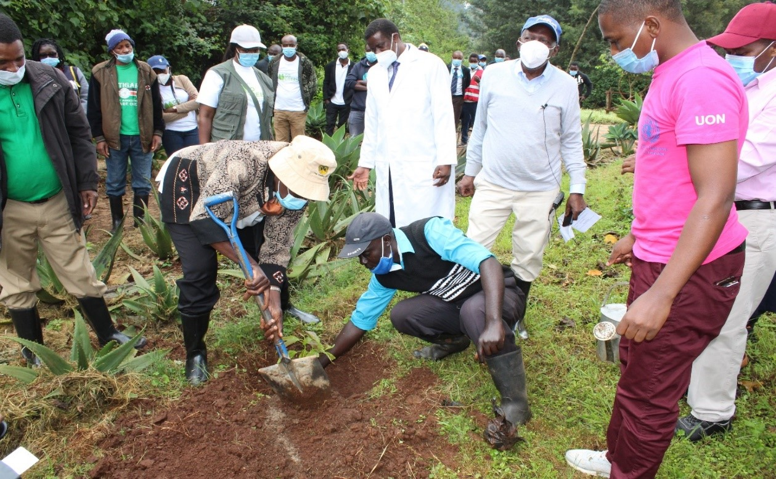Prof. Rose Nyikal (Principal, College of Agriculture and Veterinary Sciences) assisted by Mr. Timona Onyango plants a fruit tree seedling (grafted avocado) at the Wangari Maathai Institute on 20th November, 2020. Also presentwere Prof. David Mungai (Director, WMI), Prof. Moses Nyangito (Ag. Dean, Faculty of Agriculture) and other stakeholders.
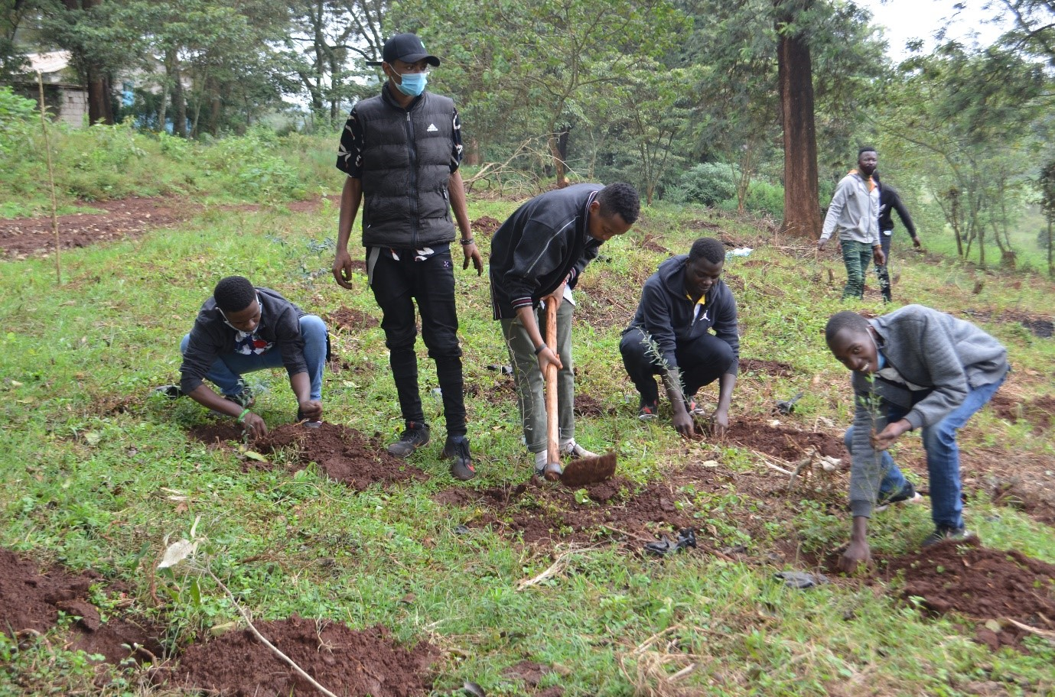
Tree planting exercise at the Kanyariri Vet Farm on 20/11/2020
The Wangari Maathai Institute in collaboration with the Green Belt Movement hosted a webinar on Earth Day 2020: Citizen Action Towards Securing Our Future held on April 16, 2020 from 3pm;
The Wangari Maathai Institute for Peace and Environmental Studies, University of Nairobi (WMI, UoN) in collaboration with the University of Copenhagen (UC) and University of Roskilde (UR), Denmark conducted an outreach and extension programme on Solid waste management in Othaya Town and environs in Gatugi, Nyeri, between February 27, 2020 and March 10, 2020. This was led by Prof. Mungai, Dr. Kiemo, Associate Prof. Müller-Stöver; A policy Brief “Solid waste governance approaches to reduce conflicts and promote human and environmental health in Othaya Sub-county” was produced.
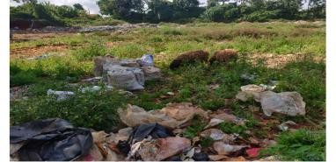

Sheep grazing in the Gikeu dumpsite (March 1, 2020)
The WMI, UoN in collaboration with the UC and UR, Denmark conducted an outreach and extension programme on Soil fertility and water management in Thuti, Nyeri between February 27, 2020 and March 10, 2020. This was led by Dr. Onyango, Associate Prof. Müller-Stöver;
The WMI, UoN in collaboration with the UC and UR, Denmark conducted an outreach and extension programme on Crop insurance scheme for maize in Kianganda, Nyeri between February 27, 2020 and March 10, 2020. This was led by Dr. Mutune, Prof. Muthama, Associate Prof. Christian P. Hansen;
The WMI, UoN in collaboration with the UC and UR, Denmark conducted an outreach and extension programme on Certification of tea in Gatuya-ini, Nyeri, between February 27, 2020 and March 10, 2020. This was led by Dr. Kiemo, Associate Prof. Christian P. Hansen;
The WMI, UoN in collaboration with the UC and UR, Denmark conducted an outreach and extension programme on Karima Hill community forest inGakina, Nyeri, between February 27, 2020 and March 10, 2020. This was led by Dr. Thenya, Associate Prof. Christian P. Hansen;
WMI conducted a mentorship outreach at Gatugi Primary School, Othaya, Nyeri County on March 3, 2020 during SLUSE;
WMI co- hosted Green Belt Movement in the celebration of the African Environmental Day/ Wangari Maathai Day March 3, 2020;
WMI co- hosted Conflict Mediation Training with Kenya Forest Service, Kenya Forest Research Institute and members of Ngong Hills Forest community service on February 14, 2020;

Major achievements, challenges and strategic projections
Major Achievements
Completion and occupation of the WMI Campus
Challenges
2020 was encumbered with the COVID-19 pandemic which may have made it impossible to undertake some research activities/collaborative activities like the PACJA initiative.

Strategic Projections

The occupation of WMI building especially the business centre, this will provide income for further expansion of the WMI.

